**SimpliLearn Phase 1 Project: LockedMe.com – Console Application Screenshots.**

**Sprint 1 : Functionality : Display Menu and Display all files.**

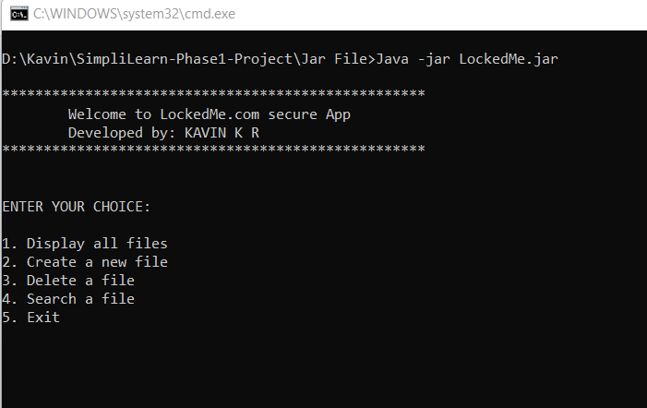

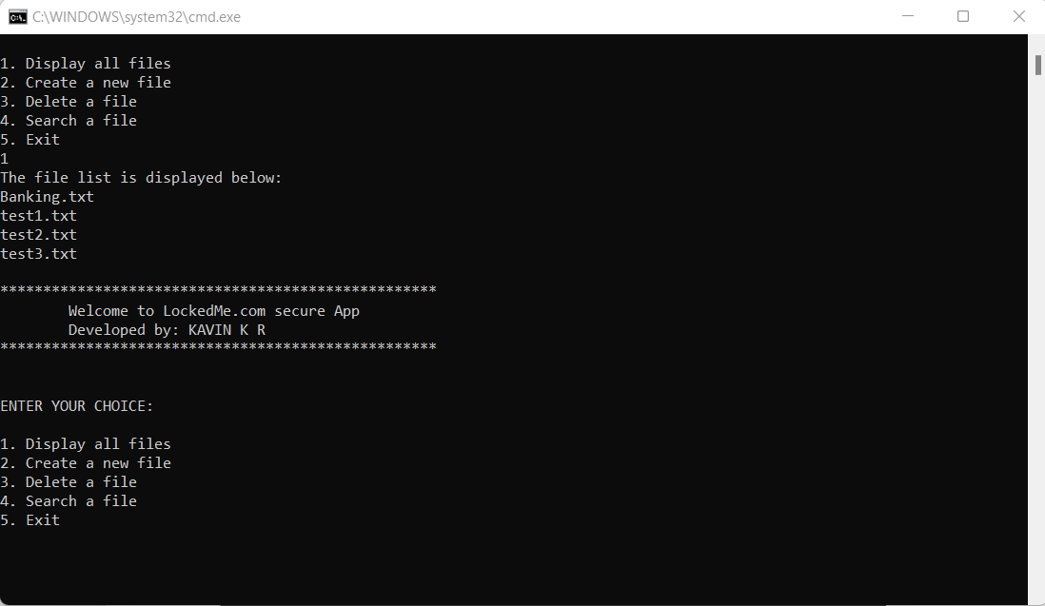

**Sprint 2: Functionality : Create a new file**

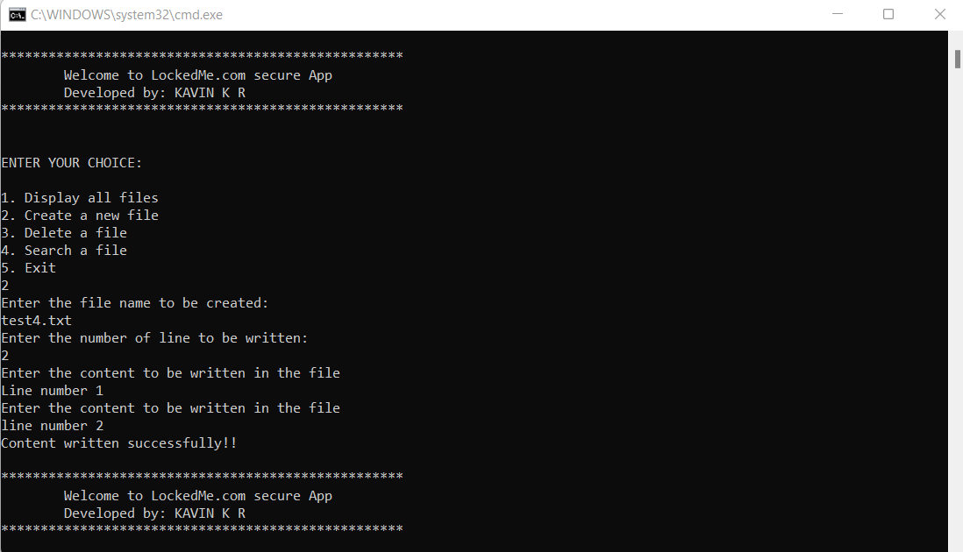

**Sprint 3: Functionality: Delete a file**

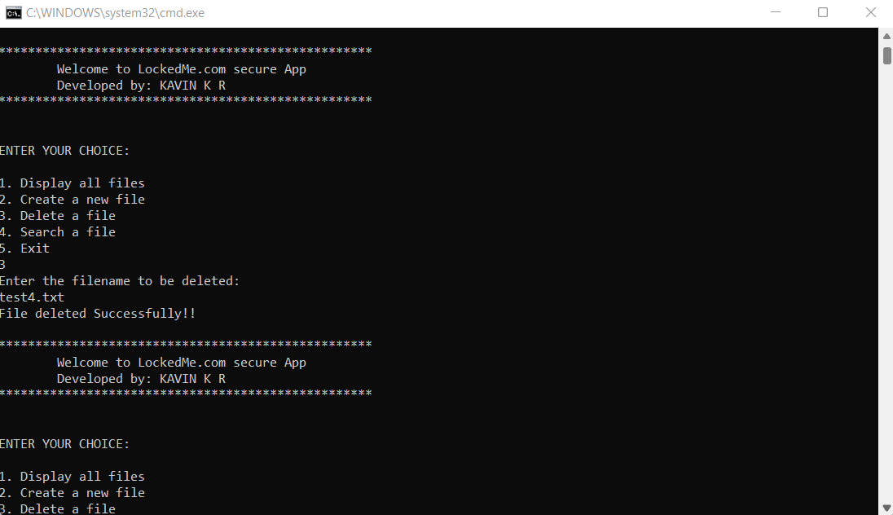

**Sprint 4: Functionality: Search a File and Exit option.**

